**ODE ON THE SACRIFICIAL LAMB**

*-Bhanushee, BVCOE*

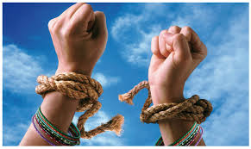

And with the dewdrops dawns another day,

She looks forward to the opportunities in the world.

For when fools friends and foes say:

”You’re nothing but a worthless slob”.

Dejected, she begs for a reason, she prays,

While believing it with all her heart.

Her elders tell her not to stray,

But emotions twisting her insides,

She wants to know why she has to stay,

When her brother is out enjoying.

“A woman I am”, you hear her say,

Trials and tribulations

Are parts of being this unfortunate race,

As life is not a cakewalk.

But look at him,

That man so gay,

He enjoys life to the fullest.

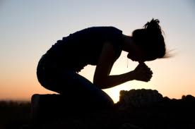“But a woman I am”, you hear her say,

That is not meant for me.

Why she does it, one cannot say,

You want to tell her to live,

As each day passes, she continues to pray,

For the wellbeing of all men living.

Ridiculous you are and the life that you live,

If you put everyone before you.

While I, me, myself is heavily condemned,

Think about yourself too.

But is she really the one to blame?

Where society plays the cards,

Her life is but a joyous game,

And the chauvinists are in charge.